AMERICANA AMERICANA AMERICANA AMERICANA AMERICANA AMERICANA AMERICANA AMERICANA AMERICANA AMERICANA AMERICANA AMERICANA AMERICANA AMERICANA AMERICANA AMERICANA AMERICANA AMERICANA AMERICANA AMERICANA AMERICANA AMERICANA AMERICANA AMERICANA AMERICANA AMERICANA AMERICANA AMERICANA AMERICANA AMERICANA AMERICANA AMERICANA AMERICANA AMERICANA AMERICANA AMERICANA AMERICANA AMERICANA AMERICANA AMERICANA AMERICANA AMERICANA AMERICANA AMERICANA AMERICANA AMERICANA AMERICANA AMERICANA AMERICANA AMERICANA AMERICANA AMERICANA AMERICANA AMERICANA AMERICANA AMERICANA AMERICANA AMERICANA AMERICANA AMERICANA AMERICANA AMERICANA AMERICANA AMERICANA AMERICANA AMERICANA AMERICANA AMERICANA AMERICANA AMERICANA AMERICANA AMERICANA AMERICANA AMERICANA AMERICANA AMERICANA AMERICANA AMERICANA AMERICANA AMERICANA AMERICANA AMERICANA AMERICANA AMERICANA AMERICANA AMERICANA AMERICANA AMERICANA AMERICANA AMERICANA AMERICANA AMERICANA AMERICANA AMERICANA AMERICANA AMERICANA AMERICANA AMERICANA AMERICANA AMERICANA AMERICANA AMERICANA AMERICANA AMERICANA AMERICANA AMERICANA AMERICANA AMERICANA AMERICANA AMERICANA AMERICANA AMERICANA AMERICANA AMERICANA AMERICANA AMERICANA AMERICANA AMERICANA AMERICANA AMERICANA

AMERICANA

OTC50 A PETER THOMAS BUSCH INC COMPANY COPYRIGHT © 2026

1776 - 2026

#1 WASHINGTON DC
#2 TITANS
#3 NEW YORK CITY
#4 CORPORATE AMERICA SERIES
#5 CHICAGO

A PETER THOMAS BUSCH INC COMPANY PUBLISHED IN VANCOUVER, CANADA $1

Passing over the mountains, and then following the tributaries eastward to the Potomac, you know you are close to Washington DC when the lush green Virginia Estate farms begin to appear.
#1 WASHINGTON DC
Those early American settlers knew where the rich soil for farming tobacco and cotton was along the tributaries.
The location of the Capitol makes even more sense when you consider the coastline somewhat sheltered the British naval vessels of King George, anchored nearby during the American Revolution.
This place is where a grand new nation was born, first settled by the Native Americans, and embraced by the first Pilgrims arriving from Europe, inevitably followed by the Imperialists and the first global corporations, before everything got thrown asunder by the Revolution.
Civil War, and the pressing need to defend freedom and democracy during The Great War and World War II, and then the Cold War, were also defining moments during a second century of nation building.
The Cold War oppositional forces to freedom were seriously aggressive foes with the same intent on expansion as the former empires that had just recently collapsed into independent states.
Even before you get lost walking along the time bridge that the National Mall incrementally becomes though, you get a sense in those first few minutes on DC ground, that everyone you see may very well be some sort of spy involved in misdirection and misinformation, and that everyone is watching and ready to call you in to some agency and some government of some sort.
The Washington Monument, which has the honor of being the world’s tallest obelisk at 554 feet and 7 inches, commemorates the contributions of George Washington to the national fabric as Commander in Chief of the Continental Army during the American Revolution from 1775 to 1784 and as the first President of the Republic from 1789 to 1797.
The obelisk dominates the skyline as a singular structure striking the center point of the National Mall with other monuments, built in the Greco-Roman architectural style with columns adorning the buildings, connected to that one obvious point.
The recently completed Martin Luther King Jr. Memorial, the newest monument, exemplifies a grand but modest approach to celebrating American icons.
King is there but he does not tower over you. Lincoln sits 70 feet in height, but the Lincoln statue in dominating the space remains inviting and embracing with sufficient presence to allow strangers to walk up and take a picture.
I jumped on the Metro at Union Station, which is just a few blocks from the bench of the highest court in the most powerful nation in the world, and spent about one hour at the place of President Abraham Lincoln’s Assassination on April 14, 1865, just a few weeks after his inauguration for a second term. The Presidential Inauguration is now always on January 20.
Ford Theatre allows access to the seating area as well as a downstairs museum and the rooming house across the street where the mortally wounded Lincoln was taken for his last hours, ultimately dying the next day at 7:22 am.
The street between the buildings had already filled up with hundreds of torch bearers showing up in support of the 16th President of the United States before he was brought over.
A brisk walk just a few blocks over gets you to the National Portrait Gallery and the American Art Gallery. This three floor museum has two mezzanine layers on the third floor.
Before I left Washington DC, I had to have a meal of chili, and a half smoked chili dog. And I also had to see the Old Town spread along King’s Street all the way toward the water of the Potomac River.
Alexandria has a nice waterfront lined with pubs and restaurants and outdoor extensions of the restaurants, with the breeze, although a warm breeze, coming off the Potomac water. King’s Street is lined with low rise and single story shops that look like they were constructed after the American Revolutionary War, or perhaps are what was left after the Civil War a century later.
Washington DC and Alexandria were very much the dividing line between the Unionists of the North and the Confederates to the South.
Arlington National Cemetery was the plantation of Confederate General Robert E. Lee. And only after the Unionist pushed Lee and the Confederates off their land in Washington and Alexandria did the 639 acres become a burial place for the military dead on May 13, 1864.
Alexandria is really the Old Town, whereas Washington as the Capital had moved a few times, including from Philadelphia and from Baltimore, until settling for a spot in and around the National Mall, the obvious centerpiece for a nation now approaching 250 years of history, and a couple of hundred years before that as settlements that became townships and then colonies, before becoming an independent nation.

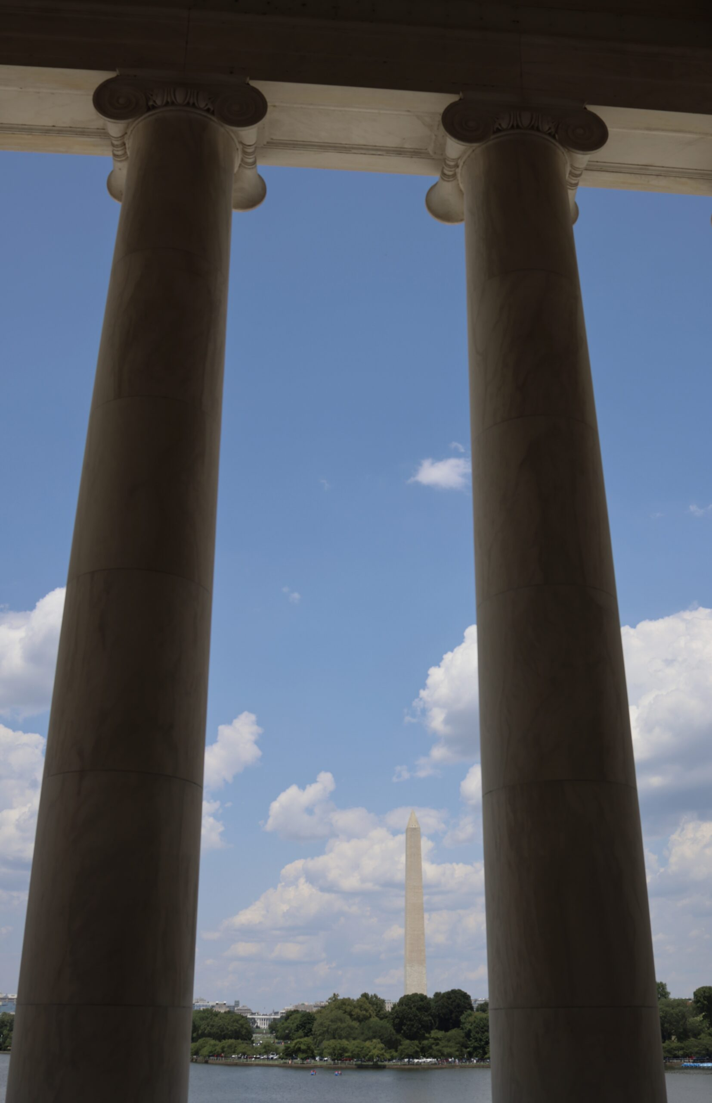
The world marketplace has become ruled by more than just eCommerce barons. The global economy is run by oligarchs, capitalists, innovators, outright no-holds bar imperialists, and sometimes heads of state.
#2 TITANS
These over achievers seldom set aside economics and wealth accumulation to run for political office, but once in a while, an unabashed capitalist successfully wins the leadership of the democratic world order.
Jimmy Carter was President of the United States when Bill Gates dropped out of Harvard and began designing personal computers. Gates and Microsoft cofounder, Paul Allen, earned their stature in the world by innovating something valuable for the new world order, during the golden age of computing.
The technology age was developed in fits and starts and bits and pieces, and by people working out of the garage (the requisite workspace for a Silicon Valley start-up) but eventually most small start-ups were gobbled up by the reigning magistrates of eCommerce.
Microsoft had brought the world so far from the home office in Seattle, but Gates and Allen had more in mind, like global domination for the Microsoft operating systems.
Jeff Bezos of Amazon liked the whole idea of on-line shopping, and simply deciding to keep getting bigger until the on-line book sales exceeded those of the reigning retail book seller. Amazon then expanded from a garage in Seattle into an on-line marketplace for everything, as the technology age found more ways to replace the conventional shop sellers on the street who had maintained business inside the model carried over from the Industrial Age.
That need to control the market by constantly increasing the scope and breadth of the business differentiates the richest people in the world from business owners’ content to provide for the existing demand in a distinct neighborhood.
The eCommerce titans eventually began to emerge on the world stage with rock star celebrity status, following in the tire tracks left by the celebrity of Henry Ford.
Ford invested in the new world imperialism after rationalizing that he could build the automobile so cheap that nearly everyone could afford to purchase one. Ford’s second big idea was to construct vehicle assembly plants within separate international markets to make purchasing a motor vehicle even less expensive.
Ford’s individual imperialism not only created great wealth, but he amassed great influence with his economic power. Ford didn’t need to conquer Brazil to undertake a rubber plantation. Ford merely needed to use his great wealth to purchase land in Brazil on which to develop one.
Ford expanded within the automotive industry, eventually creating a vertical market that had Ford automobiles assembled with Ford parts, right down to the rubber for the rubber tires from that plantation in Brazil. But Ford eventually stayed with what he knew, building cars, so much so that he resisted the need to design and build a new model to replace the aging Model-T, and only begrudgingly considering changing the colors.
When Charles Lindbergh flew the Spirit of St. Louis across the Atlantic on May 21, 1927, the world became a much smaller place for everyone, including for the captains of industry. Wikipedia points out though that Lindbergh was not the first to fly across the Atlantic, just the first to get the job done solo.
Empire gave way to the concept of Superpower, and a central system of economics influencing distinct cultural and linguistic entities in places beyond the borders until the world was broadly divided between capitalist democracies and communist dictatorships, and nary every variation in between.
The corporations, and their capitalists leading them relentlessly onward, held on to power. Of course, the transitions were not so simple, with many states being formed only as a result of military conflict. The United States of America expanded territory from the Eastern seaboard to the west coast by fighting the indigenous populations, and then by turning south to fight the Spanish and Mexicans for the southern border.
Make no mistake, the wealthy aristocracy became the architects of the American constitution, and the independence from empire was hard fought for over many years, in the same way the rich kids from Seattle and Silicon Valley created the blueprint for the technology age, with relentless determination.
Benjamin Franklin developed a blueprint of hard work, celebrity and wealth accumulation, leading to expansion, for an elite class of capitalists to replicate, whether they recognize the influence as such or not. In many instances, celebrity comes first.
Celebrity can be a powerful ally to innovation, providing the pivotal component in convincing people of the likely success of further expansion when industry might otherwise hesitate to accept change. Everything else just accelerates exponentially ever thereafter.
Larry Ellison of Oracle designed data software for large corporations. But in the end, getting more media attention than Paul Allan of Microsoft was just as important to the rockstar capitalist. In an era dominated by popular culture, the billionaires fought to maintain a historical footprint, just as much as the musicians and the movie stars did.
The titans did not just come by their wealth one day, nor is the money old money passed down from previous generations. A particular entrepreneurialism created the success on the scale not experienced before there were titans of the technology age.
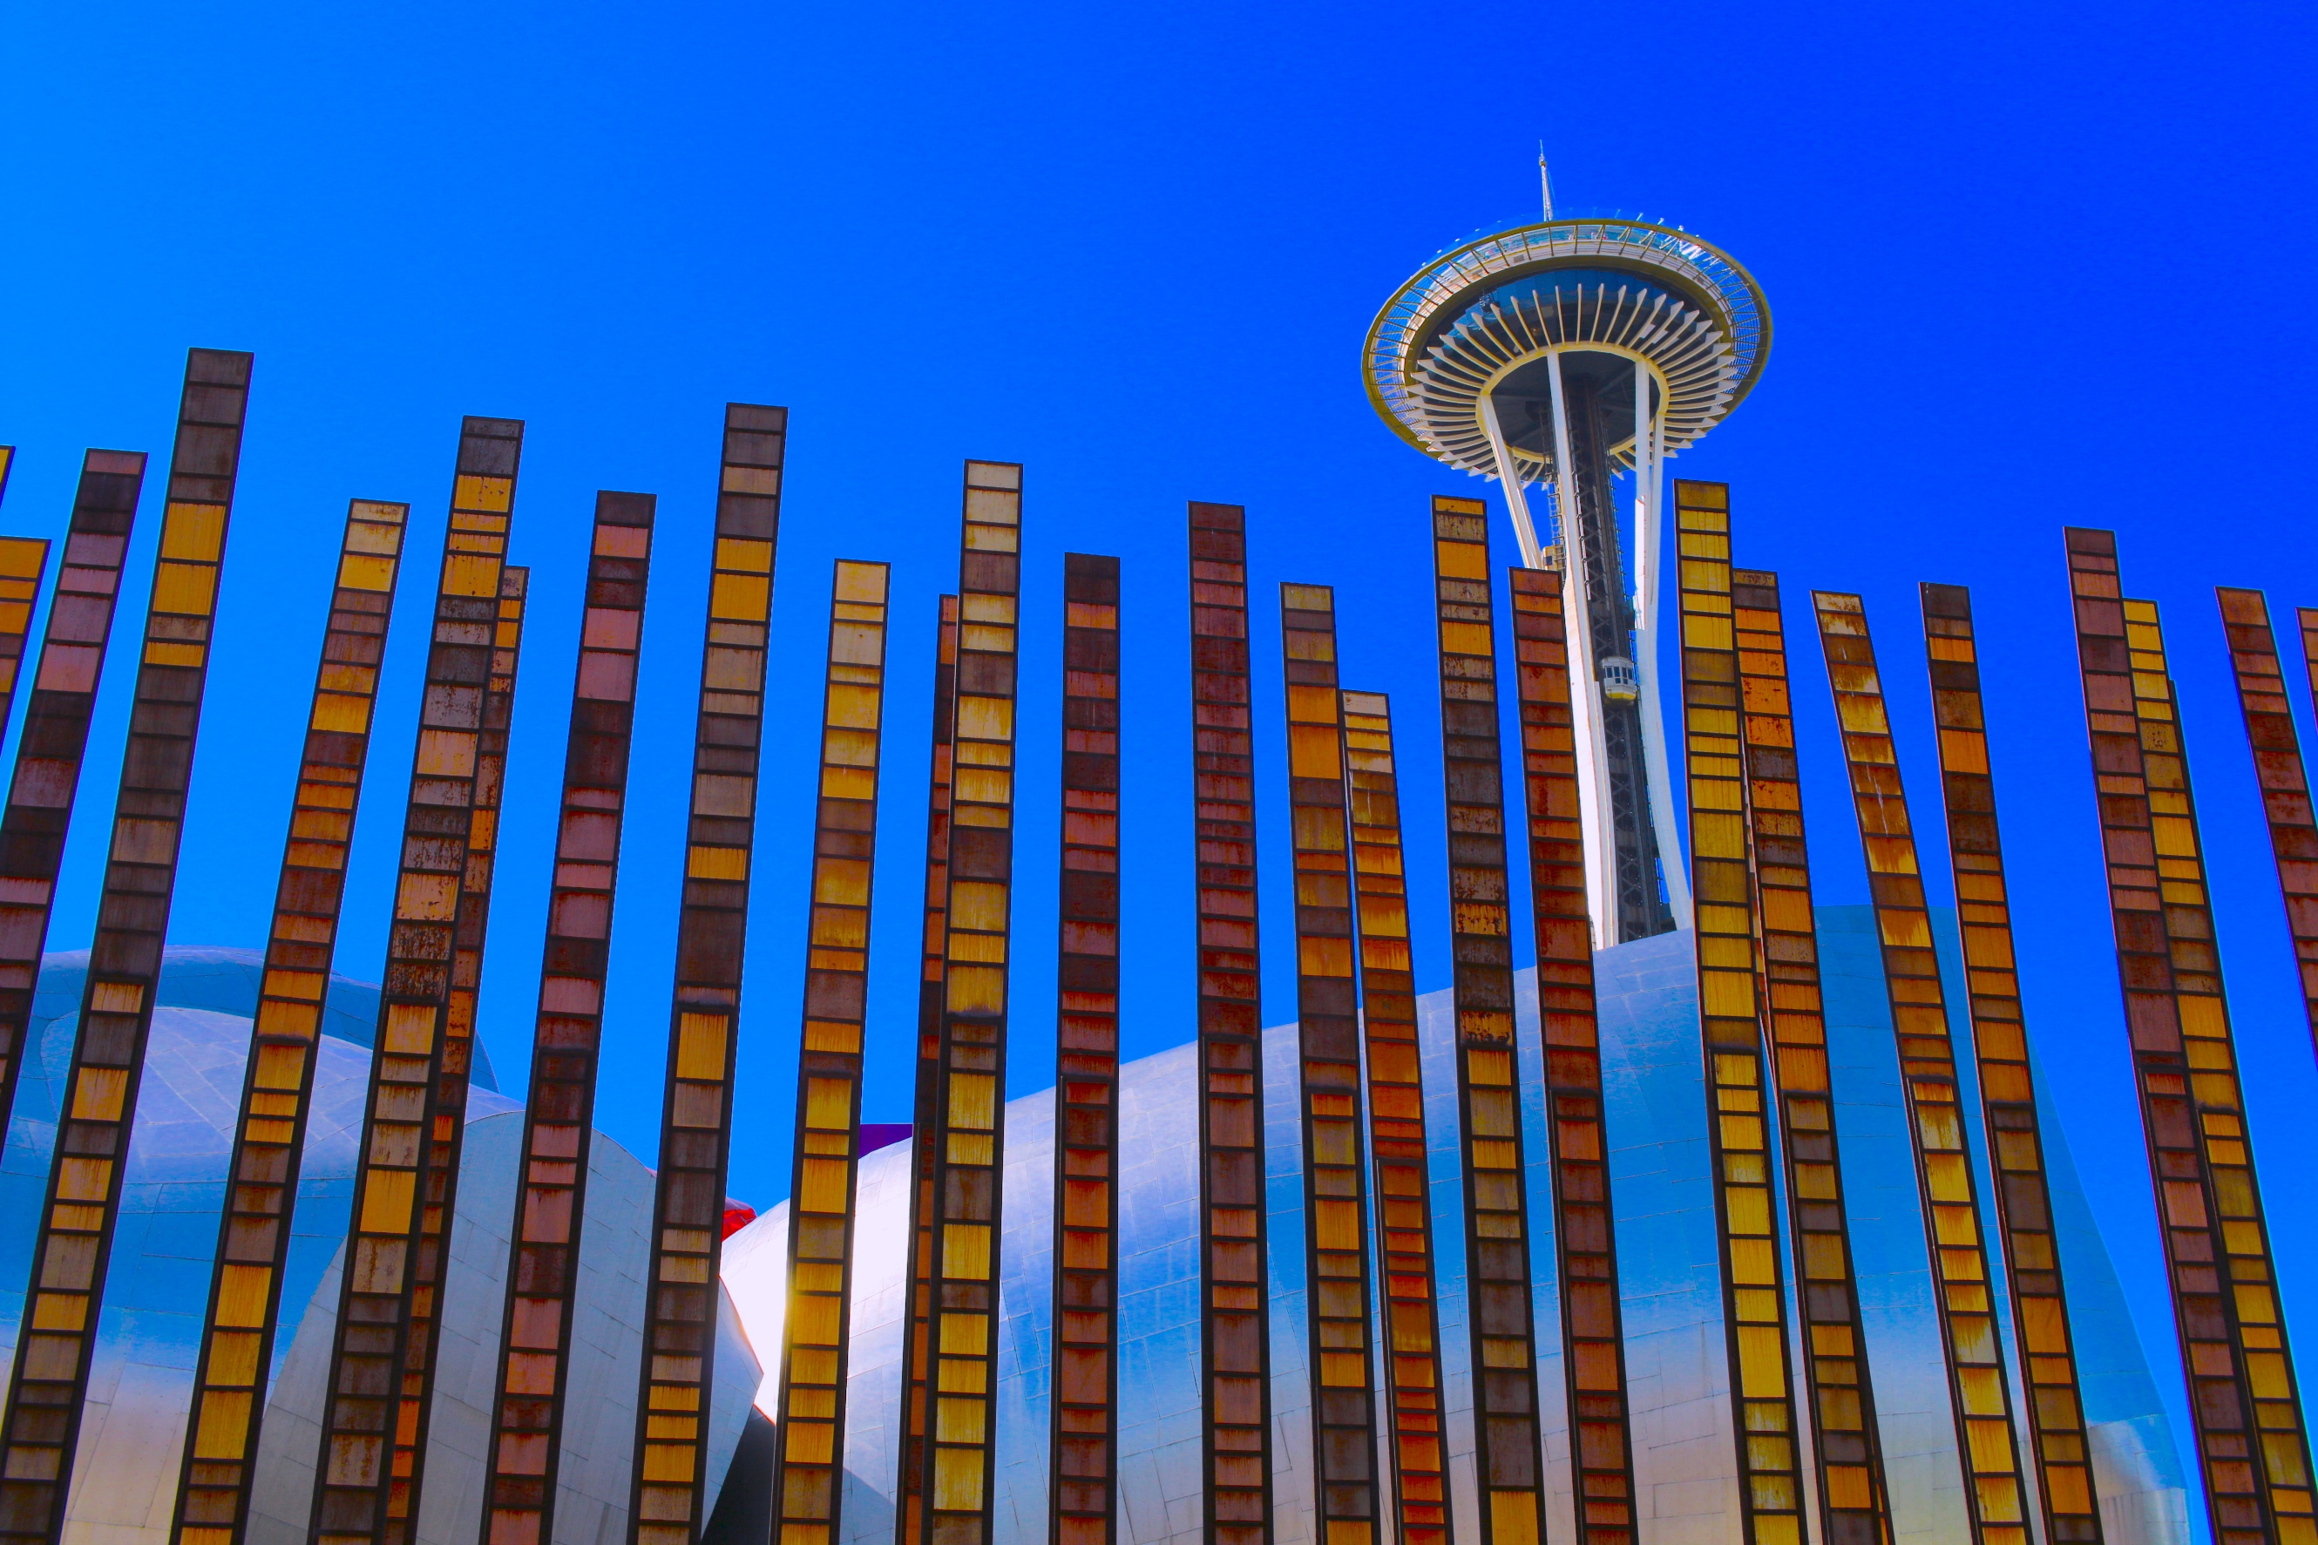

New York City shows down below through the soft clouds as a place of civilization with no beginning and no end.
#3 NEW YORK CITY
One instantly feels special descending gently through the airspace, inevitably dipping individual consciousness into the collective consciousness of a greater world, to become forever altered by the experience of time and space of one of the most iconic cosmopolitan cities ever created for civilization.
Industrialists built this complicated city into the present form – perhaps the world’s most influential city and most liveable cosmopolitan city operating all day long and all night long seven days a week.
In Manhattan, builders raced against builders within the city and against builders in other cities like Chicago to be the first to construct bigger taller, better skyscrapers with such determination that Manhattan now stretches into the clouds from end to end 100 years later.
Engineered steel frameworks support light curtain walls of glass and stone so that towers can reach further into the sky as never before possible. Then the development of high speed elevators enabled builders to go even higher and higher. Tenants and visitors no longer had to worry about taking the stairs up 10 floors now that the machines enabled people to travel up high, perhaps 20 and 30 floors at first until the Empire State Building was constructed as the tallest skyscraper at 102 floors.
The Empire State Building still looms imposingly over the city today after construction completed on Fifth Avenue in 1931. The Art Deco building earns more money annually on visitors to the 86th floor observation deck than on rental income from business tenants.
New York City remains very much an open city despite the ongoing threat of terrorism and recurring street gun violence. You can still eat a piece of New York style cheesecake inside Grand Central Station just to watch the show of people going somewhere, coming from some place on the many regional trains and buses using the Central Terminus since 1871.
New York City is grand. So grand, visitors may not want to find themselves in the south end having to race north to a venue or event during the same day to enjoy a few hours in one of the many art museums in that part of town.
The morning at Liberty Island walking around the Statue of Liberty dissolves away as does the afternoon at the north end of Manhattan for four hours or was the time marked at five hours at the Museum of Modern Art. Time passed differently during travel between the two points.
Just to avoid too much disappointment, the observation deck of the Liberty Torch has been off limits for safety reasons since 1916, even if you have tickets to the Statue of Liberty. So just forget about leaning against that railing on the Torch deck to take pictures of Manhattan and perhaps a selfie with the golden Torch in the background because no matter how much you wanted to do that, you just can’t, even if you want to pay to stand out there. Maybe try a green screen.
What you can do is get lost in Chinatown for free, trying to find a shop in Little Italy that sells perfect Italian mozzarella.
Lower Manhattan was originally a trading post in 1624. Eventually Lower Manhattan and four other cities were amalgamated to form the one larger New York City. Manhattan is the Inner City with the business and financial districts as well as the iconic attractions such as Central Park and the Chrysler Building.
Brooklyn, Queens, The Bronx and Staten Island form the other boroughs of New York City that have distinct urban cultures. Inside each borough are the iconic neighbourhoods, such as Tribeca, the Five points and Harlem inside Manhattan, while the Brooklyn Bridge stretches from Lower Manhattan to Brooklyn.
People can make the walk across the Brooklyn Bridge, if for no other reason than to enjoy historical time simply melting away in the sun.
The Brooklyn Bridge joined the borough of Brooklyn with the borough of Manhattan on May 24, 1883, 13 years after construction began. Two dozen workers died during construction, including the lead design engineer, John Roebling.
After the American Civil War in 1865, and with the Great Migration of Blacks to the northern industrial cities thereafter, about 40 per cent of the workforce in Brooklyn took the ferry to Manhattan before the bridge was built. The Brooklyn Bridge was the world’s first steel-cable suspension bridge.
The first day in this spectacular international city is difficult on your sensory perceptions. And so, that may be the days end for the sights and other attractions since just getting off the plane and walking through the airport is a bit of a mental circus, as one gradually becomes immersed in this iconic cosmopolitan culture.
Visiting New York City was such a dream built up from hundreds and hundreds of pop culture references in real politic and entertainment media over a lifetime that all of reality comes crashing down at once. All the images start to swirl around in your head with all those movie scenes and going-ons reported on primetime news over the years.
New York City is so wonderful, and the people are just so fine that a huge metaphysical down cycle awaits visitors returning home like culture shock experienced through the rearview mirror.
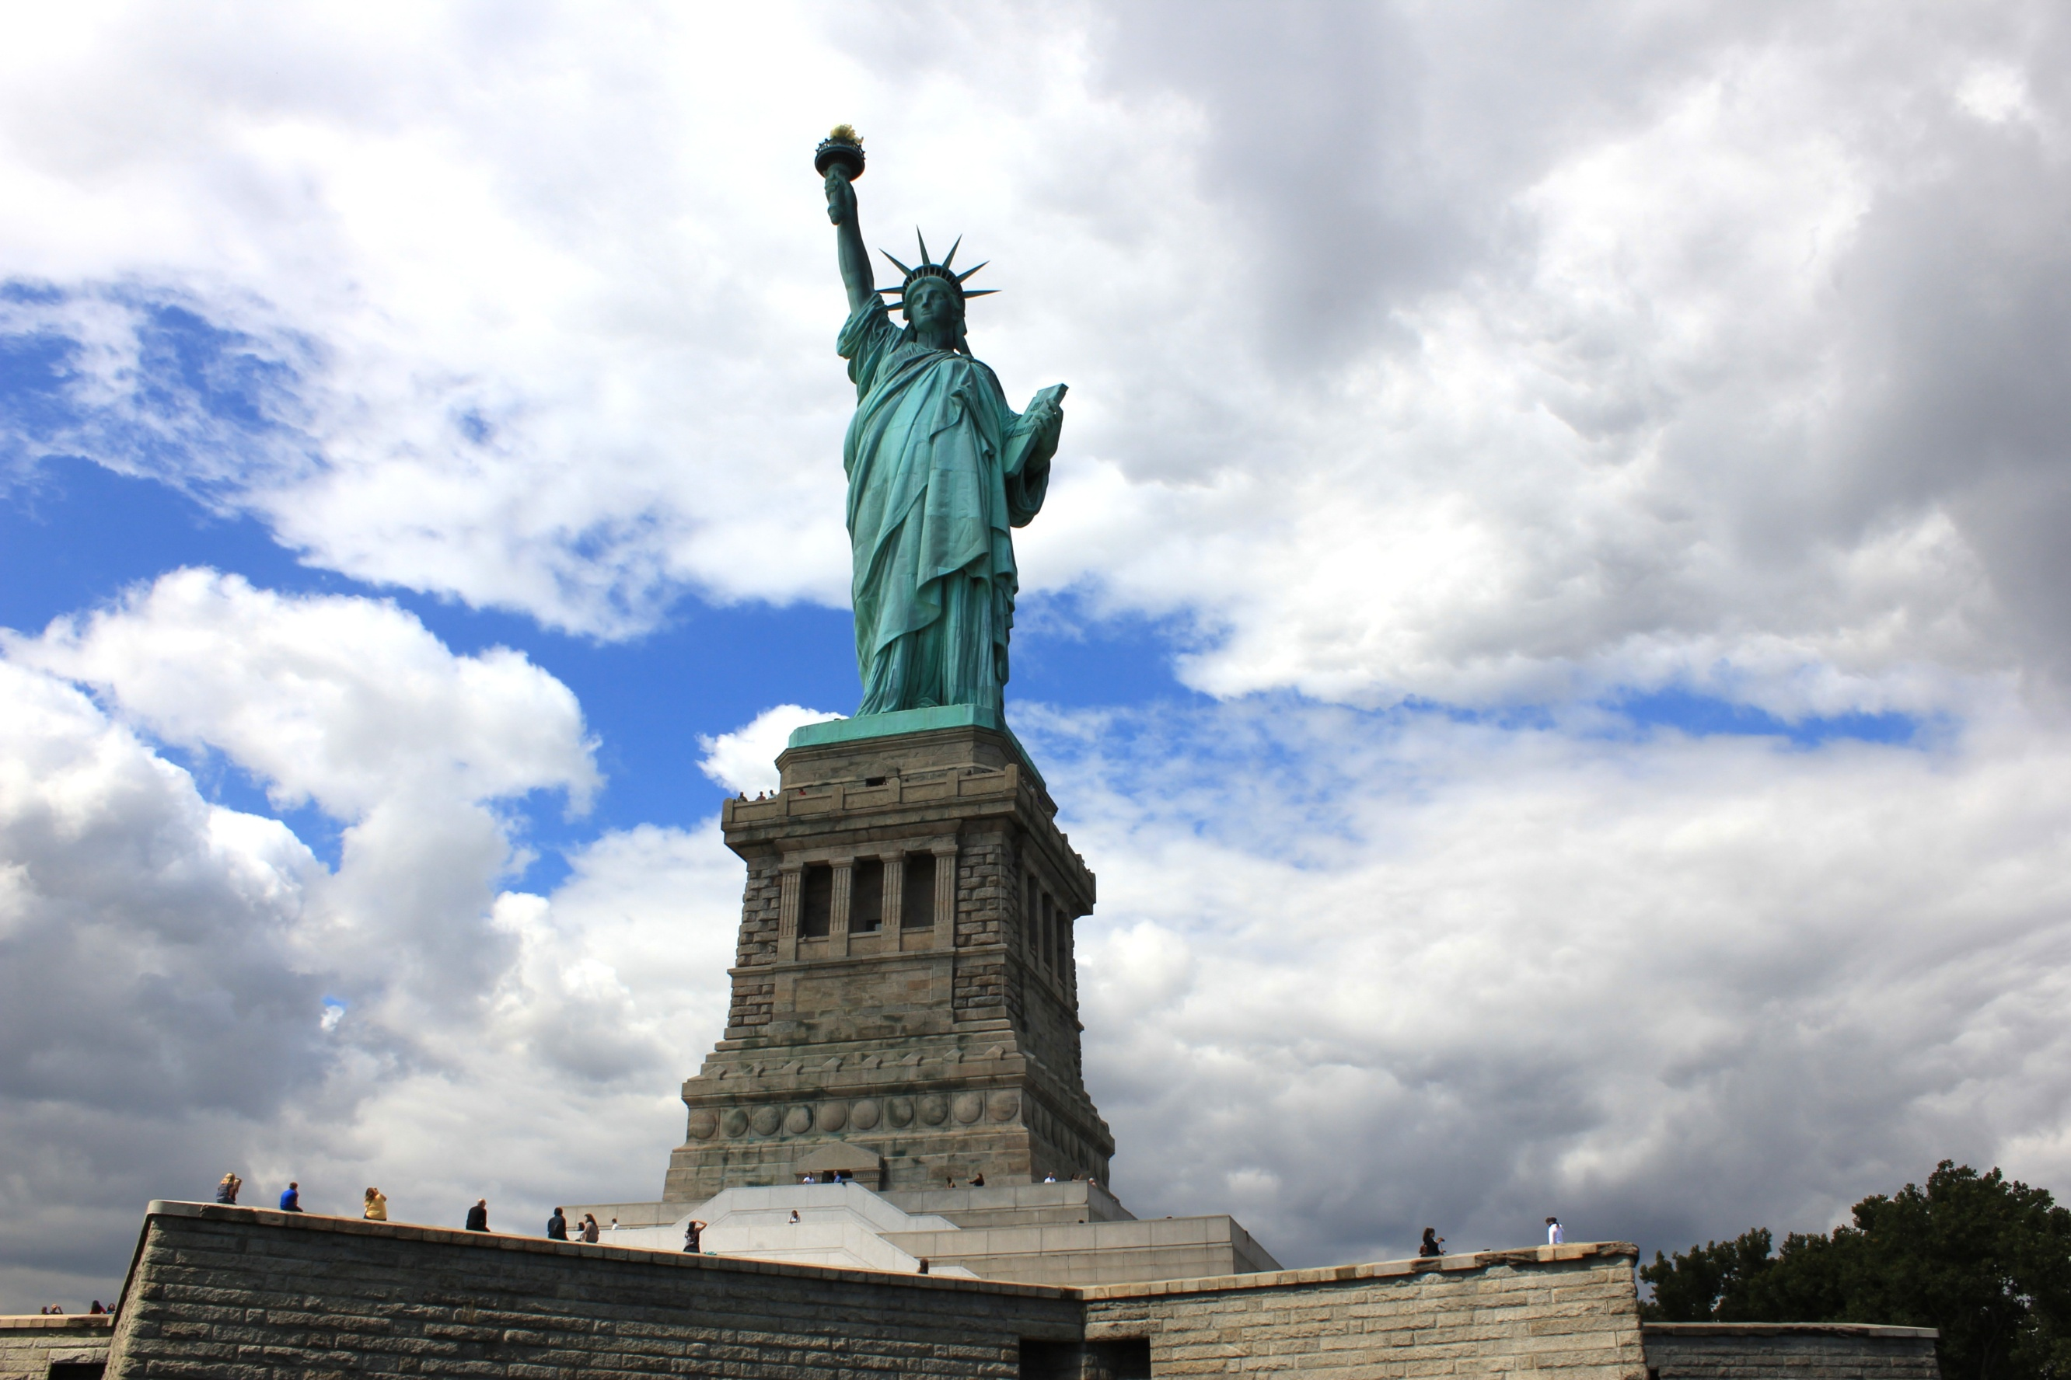

The loyalty of the corporate citizen remains illusory when the legal entity expends more resources imbued in self interest than providing benefits to the community.
#4 CORPORATE AMERICA SERIES
Corporations too often take more value from the individual than that invested into the community while the push for open societies becomes an avenue for economic expansion.
Democracy becomes imperilled through this process. Democracy should be instead a mechanism for distributing equal shares of dignity and economic power throughout the classes.
The state however tacitly colludes with Corporate America to manufacture a public image that capitalism and democracy fit together. Capitalism though has less to do with democracy and justice than collecting profits for distribution among the few corporate shareholders and even fewer corporate executives.
Only the very wealthy citizens in the top thirty per cent of income earners have direct influence over the government, while a small fraction of the top one percent have unlimited power and influence, often involving direct contact with government officials.
Wage earners become increasingly limited in an existence centered on the need to get paid and the difficulty of living day to day on that working wage. The illusion of equality is maintained while power and wealth become increasingly concentrated among fewer people with each new economic cycle. The wealthy gain more and more power and influence the more wealth accumulates.
People become displaced through the economic turmoil, while corporations survive by passing the burden of economic hardships from manufacturing to the individual taxpayer.
Future generations become indebted for the environmental cleanup that the employer has left for everyone’s children. Profits are realized in the immediate present while the cost of production becomes deferred for decades, long after manufacturing plants shutter.
Invariably, the consumer chooses the reduced cost of the product that the manufacturer can now market, but consumers pay for the cost savings indirectly through the taxes used to pay for the social and environmental costs of production.
The corporate image remains constant despite government intervention, because success in America is measured by the Wall Street share value. If the price of corporate shares rise, that’s good Americana, without any second thoughts of how that profit was made.
Money goes out to create the image, but money also comes in, through consumer purchases, and often government contracts that maintain corporations through economic downturns.
Corporations may create horizontal markets, selling one product publicly as part of the corporate image, and other not so favourable products in different markets, perhaps twice removed from the public consciousness.
Corporations may also legitimately assemble vertical markets in which the supply chain can be controlled, but some corporations have so many vertical markets that the business enterprise operates in an oligopoly.
The corporation appears to be operating a horizontal market, but the free market has become a near monopoly enterprise in which only a few oligarchs influence the social, economic and political levers.
One less regulation benefits many corporations. This quite agreement among corporations in oligopolies erodes the value of democracy. Wealth is concentrated, and power is concentrated, and then more wealth is concentrated in a perpetual cycle that gradually excludes more and more of the public.
Wealthy people ultimately then influence the enactment of legislation that entrenches their influence on democratic political power. In this way, legislators assist capitalists in developing capitalism to overtake democracy in importance.

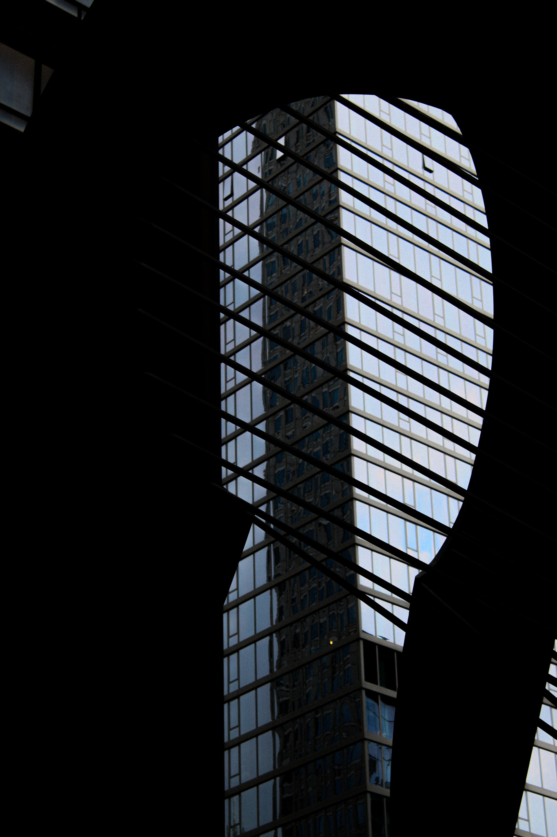

#5 CHICAGO
Industry along the lakeshore had drawn people from the American South looking for jobs in Chicago after the American Civil War and the Great Migration of former slaves leaving the cotton fields of the south for the steel foundries, factories and meat packing plants of the north.
People looking for real jobs to support a family were willing to leave the history of the American South behind.
Chicago also had a chance to start over again, just as the freed Black slaves did, after a great fire drove people to the north and to the south of the city looking for shelter. The city was left a barren vacant lot for redrafting after the wood tenements incinerated in a fire storm.
The great city plan for a new beginning would reclaim the lakefront from the railways and industry, thereby transforming private company land into public common areas, and creating an accessible shoreline now 29 miles long, adjacent to an expansive boulevard constructed out of America’s love for the automobile.
The Greet Depression took a lot out of those plans for Chicago, but like any great city, the streets and the people changed with the times, and the city survived in that way, always part of the landscape and part of the interactions people make with the streets in any given circumstance as history has been repeatedly left behind for a less predictable future.
The plains and the lake and the river were left open for the public to enjoy while behind Michigan Avenue the buildings grew just as tall and majestic as anywhere else in America - blotting out the sun and the clouds and the sky, but not so much as shelter from the rain in Chicago as from the winter wind and the bitter cold that blows in across the lake in Chicago.
The downtown business district circumvents the Chicago River. Rather than fight that river and the harsh weather of the Midwest, the city was dug inside and around and overtop of the river loop. Twenty steel bridges of all sorts of engineering designs enable the streets to continue from the lake over the river and outward toward the lands far beyond the concrete, glass and steel towers.
The city also built a transit loop, as an industrial age reflection of that river loop, built atop of a steel platform allowing trains to travel 1.79 miles around the business district, joining other transit lines heading out of the city, even joining the ghetto loop to Englewood.

The rapid transit trains clamour by overhead every few minutes – a bit loud and distracting for a first time visitor, but after a few days, the sound made by the train wheels against the hardened steel rails becomes part of the charm of a place made by industry and commerce and gangsters.
The Prohibition Era left an indelible mark on Chicago – everyone worldwide will always know of the organized crime running illegal alcohol sales. The gangster hideouts are few and far between now, having fallen to the gentrification of former gangster neighbourhoods, but the gun shots can still be heard underneath the rumble of the rapid transit trains elevated on steel trestles, built over one hundred years ago before the time of John Donato Torrio, Al Capone, John Dillinger and the National Crime Syndicate, and in the stillness of nights on the South Side.
The neighborhoods still get torn apart by gun violence, as surely as the bitter wind off the lake and the winter cold can still make a body bend in hurt.
Chicago is in this place for a reason only God knows.
United States President Abraham Lincoln was nominated in Chicago before becoming United States President and leading the country into a bloody civil war against the secessionist and slave owners of the South. The battle between continental brothers was so dearly fought for that America would become transformed when everything was all said and done, and the dead were buried, including Lincoln.
The Democrats had a go at it, over one hundred years later when the Inner Cities of America were burning and the civil rights activists and anti-Vietnam War protestors took to the Chicago streets at the Democratic National Convention just a few months after civil rights leader Martin Luther King Jr and Democratic Presidential hopeful Bobby Kennedy were assassinated.
John Lewis and Jesse Jackson were with King at the Lorraine Motel in Memphis on April 4, 1968. Lewis and Jackson would continue on in Chicago, without the great civil rights leader, and push for civil rights reforms and Black dignity in Washington, DC.
United States President Barack Obama was so compelled by the context that he moved from New York to Chicago as a recent college graduate and began working as the director of a community outreach non-profit.
The history of violence and the politics of discontent has become just a caricature of a city rich in culture and mystique. Chicago has changed with the context, except for the landscape, with the prairie stretching right to the lake and the only mountains being the ones made out of concrete, glass and steel.
And a cool wind blows off the lake during a heat wave.

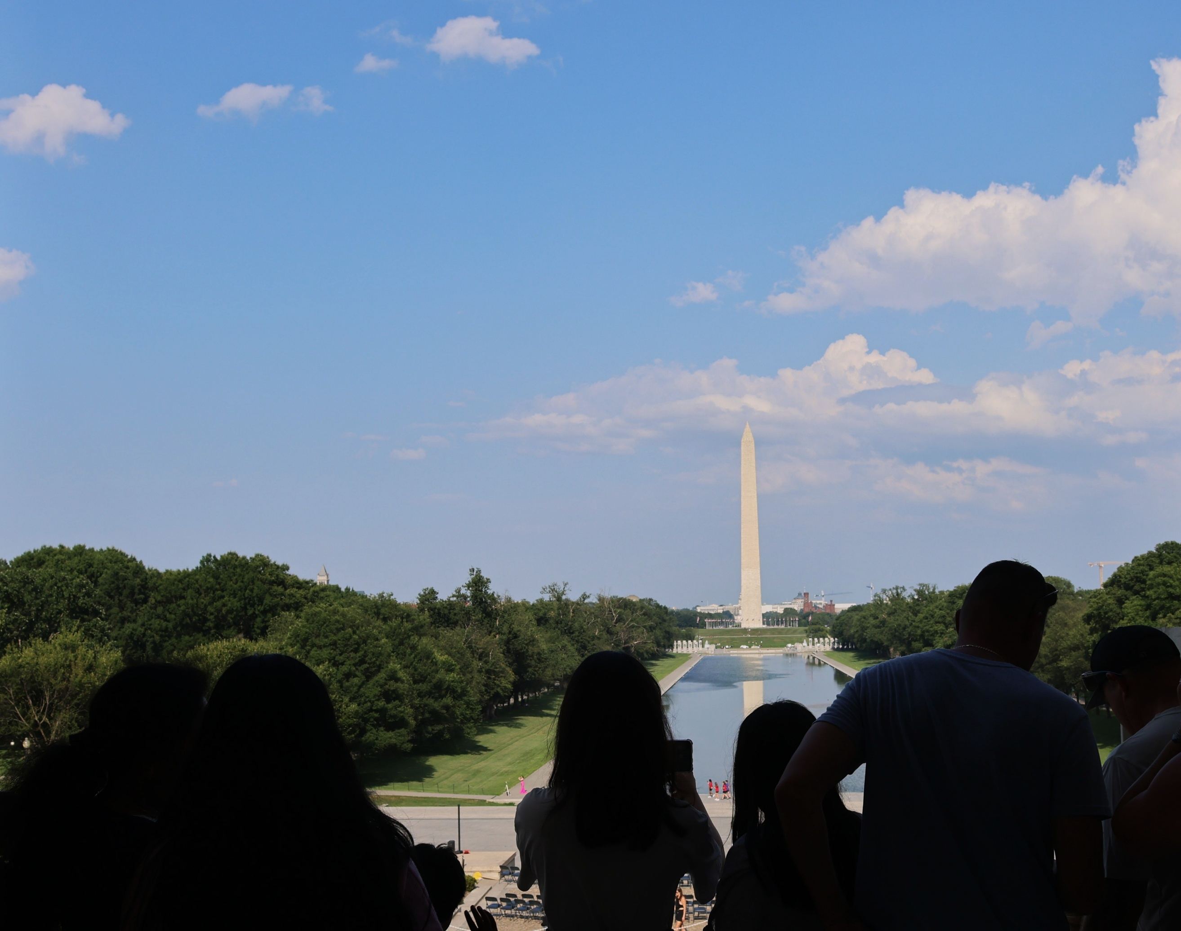

- OTC50 A PETER THOMAS BUSCH INC COMPANY COPYRIGHT © 2026

